**Machine Learning**

Assignment - 2

1. **Linear regression:**
2. **Perceptron:**

Approach :

We have tried to achieve a hyper-plane that best separates the given data. To achieve the parameters for this hyper-plane, we did the following:

* We selected 70 random examples as training set and remaining 30 examples as test set
* After initializing the weight matrix, we performed gradient descent to reach at the optimum weight vector
  + We continue calculating the gradient and updating the weight vector until the gradient becomes less than a specified theta(or threshold) value.
  + We have also plotted the mean squared error against the number of iterations to visualize the convergence of gradient descent.

With the final weight vector, we calculate the training and test set error by comparing the predicted and actual labels of data points.

Following are some common outputs:

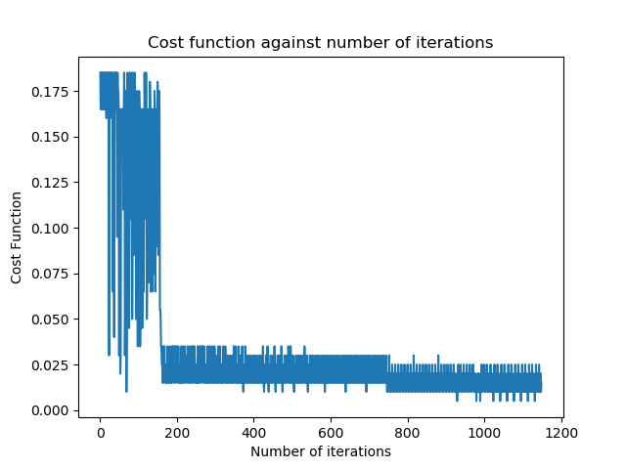

Training set error: 2.857142857142857 %

Training set accuracy: 97.14285714285714 %

Calculated weights: [-0.04590000000000018, -0.04993999999999965, -0.04525000000000039, 0.07098999999999986, 0.08341999999999856]

Test set error: 3.3333333333333335 %

Test set accuracy: 96.66666666666667 %

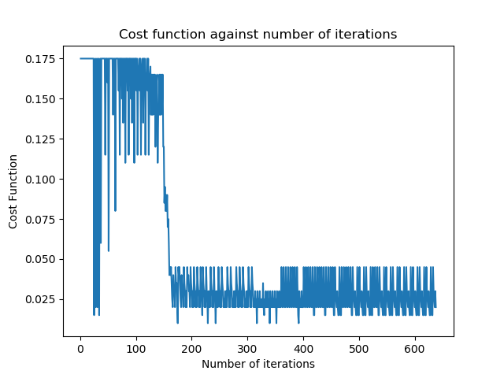

Training set error: 2.857142857142857 %

Training set accuracy: 97.14285714285714 %

Calculated weights: [-0.05260000000000005, -0.06747000000000068, -0.06030000000000073, 0.09769000000000058, 0.09543999999999919]

Test set error: 0.0 %

Test set accuracy: 100.0 %

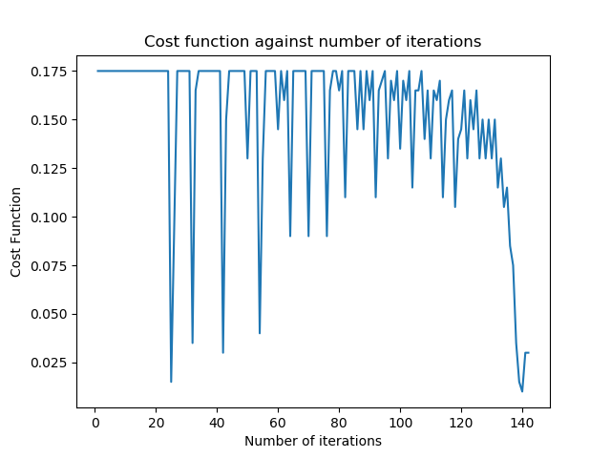

Training set error: 0.0 %

Training set accuracy: 100.0 %

Calculated weights: [-0.03560000000000005, -0.07616000000000012, -0.05695000000000006, 0.10731999999999983, 0.08525999999999999]

Test set error: 6.666666666666667 %

Test set accuracy: 93.33333333333333 %